Q1. Difference between function expression and function declaration with example?

=>

* Function declaration variable gets hoisted but function expression does not get hoisted.
* Function declaration has a name but function expression does not have name it is un-named and also know as anonymous function.
* In JavaScript function declaration is rarely is used it used always function expression.
* Only ES5 function declaration gets hoisted.

Example:

Var v1;

It throws error because variable does not get hoisted

V1(“abc”);

V1=function(one)

{

Console.log(“one”, one);

}

Var v1;

Now the function gets executed and variable gets hoisted

V1=function(one)

{

Console.log(“one”, one);

}

V1(“abc”);

Var Rohit = function(name)

Function assignment

{

Console.log(“name”,name);

Name();

}

Function calling()

Function declaration

{

Console.log(“employee”);

}

Rohit(calling);

Q2. What do you mean by first class citizen in JavaScript and what are first class citizen in js

=>

* In JavaScript function and expression is first class citizen.
* 1st class citizen can go anywhere and do anything.
* Function can do anything.
* Function is non-primitive or kind of variable which holding reference to a function.
* Function can override function with same name.
* It can acts as an object or class.
* We can passed value to function.
* It can be a key value pair
* It is a part of variable.

Q3. What will be the output of 1st and 2nd console and why ?

1. var obj = {

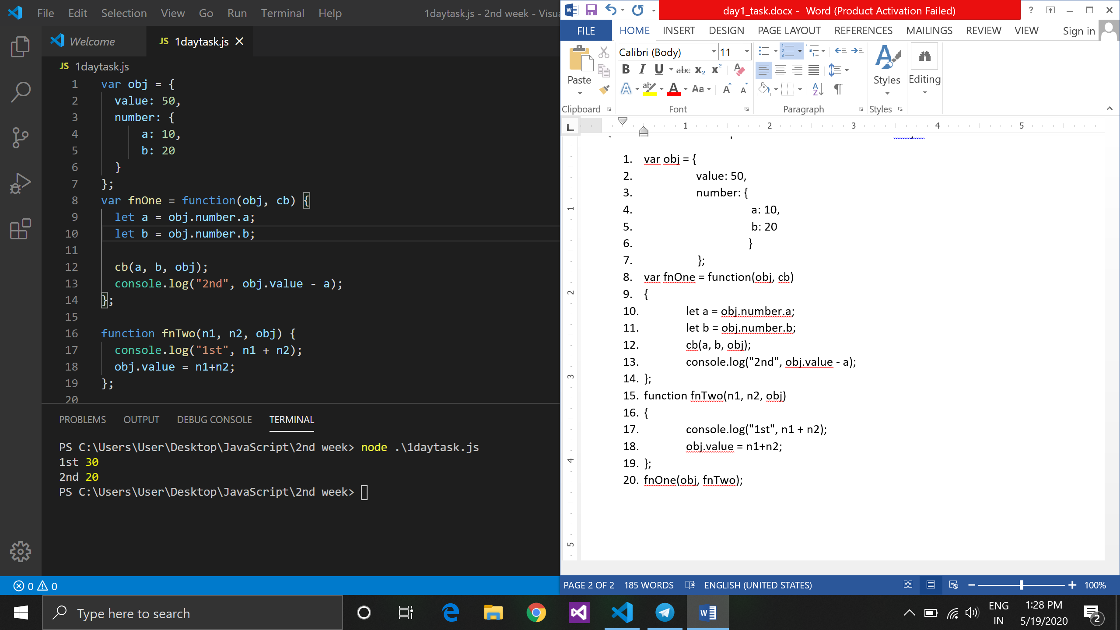

1. value: 50,
2. number: {
3. a: 10,
4. b: 20
5. }
6. };

Function assignment,expression

1. var fnOne = function(obj, cb)
2. {
3. let a = obj.number.a;
4. let b = obj.number.b;
5. cb(a, b, obj);
6. console.log("2nd", obj.value - a);
7. };
8. function fnTwo(n1, n2, obj)

Function declaration

1. {
2. console.log("1st", n1 + n2);
3. obj.value = n1+n2;
4. };
5. fnOne(obj, fnTwo);

1st block contain variable declaration where value=50, a=10 and b=20. In fnTwo at line no. 17 the value of n1 is 10 and n2 is 20 so the addition become 30 and override the value of value to 30.

Then in fnOne value 0f a is 10 and b is 20 but at line no. 13 ( obj.value = 30, a=10) so ans is 20.